Module ‘Launcher’

This Module contains shortcuts to commonly used apps and folders, during the Packaging process.
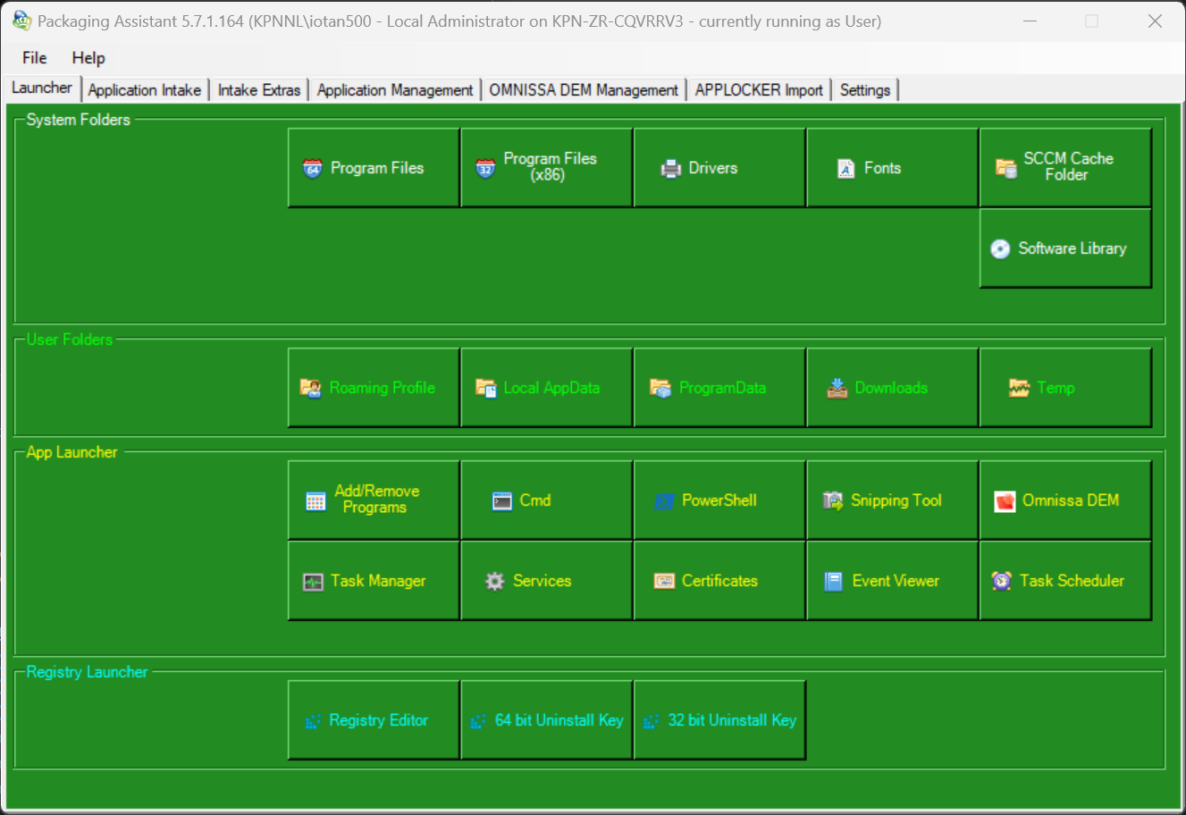

- Feature System Folders
This Feature contains shortcuts to commonly used System Folders, like Program Files.

- Feature User Folders
This Feature contains shortcuts to commonly used User Folders, like Roaming Profile.

- Feature App Launcher
This Feature contains shortcuts to commonly used Applications and Consoles, like Add/Remove Programs.

- Feature Registry Launcher
This Feature contains shortcuts to commonly used keys in the Registry, like the Uninstall Key.

